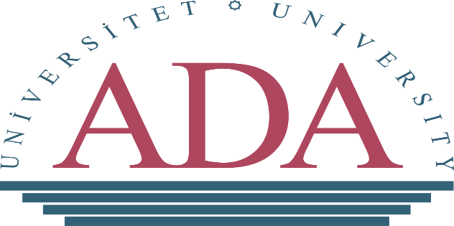

International Leadership Research Forum - Early Childhood (ILRF EC) Conference
ADA University. Baku. Azerbaijan: 29th -31st August 2022
Hosting Department: Master of Arts in Educational Management (MAEM), School of Education
Click here to join the conference online.
CONFERENCE AGENDA
Time | Day 1
29th August 2022  10:00 a.m.–11:00 a.m.  11:00 a.m.–02:00 p.m.  04:00 p.m.–05:30 p.m.  05:30 p.m.–08:00 a.m. | - Visits to ECE centres (public kindergarten in Baku City)  - Sightseeing tour  - Welcome - by Dr. Vafa Kazdal, ADA University Vice-Rector  - Welcome-by Dr. Rufat Azizov, Director of the Institute of Education  - Dinner, Networking and Entertainment
 | Day 2
30th August 2022  Keynote Addresses  09:00 a.m.–09:30 a.m.  1st Session  09:30 a.m.–11:00 a.m. | - Keynote Address on Leadership and Education in Azerbaijan– by School of Education Dean -Director- Ministry of Education Rep  - Keynote address – ILRFECE- Rep/Official  - Conference Presentations  Each session: 90 minutes (20 mins presentations and 10 mins Q&A)  - 1st Session presenters:  - Tuelo Matjokana (Lecturer, University of Pretoria, South Africa) face-to-face  - Aysel Beydullayeva (ADA University, Azerbaijan) face-to-face  - Presenters: Elina Fonsén (Associate Professor, University of Jyväskylä, Finland) face-to-face  Päivi Kupila (University Lecturer, Tampere University, Finland)  Tunde Szecsi (Professor, Florida Gulf Coast University)  Co-authors: Tarja Liinamaa (Lecturer, University of Jyväskylä, Finland)  Clarisse Halpern (Doctoral Candidate, Florida Gulf Coast University)  Marika Repo (Special Education Teacher, University of Helsinki, Finland)
Break  11:00 a.m.–11:30 a.m. | Break
2nd Session  11:30 a.m.–1:00 p.m. | - 2nd Session presenters:  - Tofig Orujov (Teacher of the Department of Mathematics, Mingachevir State University, Azerbaijan) online  - Presenter: Manjula Waniganayake (Honorary Professor, Macquarie University, Australia) online  Co-Authors: Fay Hadley and Rebecca Andrews  - Presenters: Kirsi-Marja Heikkinen (MA (Eds.) Doctoral Researcher, University of Helsinki, Finland) face-to-face  Elina Fonsén (Ph.D. Associate Professor, University of Jyväskylä, Finland) face-to-face  Co-authors: Lauri Heikonen (Post-doctoral researcher, University of Helsinki, Finland)  Emanuel Tamir (Head of Educational Management, Tel Hai academic college, Israel)  Raisa Ahtiainen (Post-doctoral researcher, University of Helsinki, Finland)  Petra Strehmel (Professor, Hamburg University of Applied Sciences, Germany)
Lunch Break  1:00 p.m.-2:00 p.m. | Lunch Break
3rd Session  2:00 p.m.-3:30 p.m. | - 3rd Session presenters:  - Ulviyya Mikayilova (Assistant Professor, ADA University, Azerbaijan) face-to-face  Eteri Gvineria (Associate Professor, Tbilisi State University, Georgia) online  - Karin Hognestad and Marit Bøe (Coordination group members of ILRF, University of South-Eastern Norway Department of Educational Science, Norway) online  - Mmapeu Manyaka (Lecturer, University of South Africa, South Africa) online
Break  3:30 p.m.-4:00 p.m. | Break
4th Session  4:00 p.m.- 5:30 p.m. | - 4th Session presenters:  - Ilaha Rasulova (Head of Preschool Education Division, Ministry of Education, Azerbaijan) face-to-face  - Matshediso Rebecca Modise (Senior Lecturer, University of South Africa, South Africa) face-to-face  Nikidi Phatudi (University of South Africa, South Africa) online  Thembi Phala (University of South Africa, South Africa)  - Mzoli Mncanca (Lecturer, University of South Africa, South Africa) online  Co-authors: Sarita Ramsaroop and Nadine Petersen
 | Day 3
31th August 2022  1st Session  09:00 a.m.–10:30 a.m. | - Conference Presentations  Each session: 90 minutes (20 mins presentations and 10 mins Q&A)  • 1st Session presenters:  - Jabulile Mzimela (University of KwaZulu-Natal, South Africa) online  - Matshediso Rebecca Modise (Senior Lecturer, University of South Africa, South Africa) face-to-face &  Hana Awad Mohamed El Hassan Ali (Open University of Sudan, Sudan) online  - Ellen Lenyai and Soane Mohapi (University of South Africa, South Africa) online
Break  10:30 a.m.–11:00 a.m. | Break
2nd Session  11:00 a.m.–1:00 p.m. | - 2nd Session presenters:  - Sharon Thabo Mampane (University of South Africa, South Africa) online &  Fazia Du Plessis (University of South Africa, South Africa) online  - Sharon Thabo Mampane (University of South Africa, South Africa) online &  Tebogo Jillian Mampane (University of South Africa, South Africa) online  - Daniel Turani (National Project Manager, German Youth Institute, Germany) face-to-face
Lunch Break  1:00 p.m.-2:00 p.m. | Lunch Break
2:00 p.m.-3:30 p.m. | - ILRF Research Groups – meetings,  - Panel discussions on Leadership by ECE expects and Questions  (Representatives from - ILRFECE, ADA School of Education, Azerbaijan State Pedagogical University, Local ECD Managers/Principals /Head Preschool Education Department at the Institute of Education, Officials from Baku City Major Office- ECD directorate).  - Resolutions on the intersections for leadership and ADA Education Leadership Programme and ILRFEC Dimensions of the leadership and way Forward – ADA School of Education and ILRF

